

MAINTENANCE CAPABILITY LISTING

REPAIR STATION BTVR626C

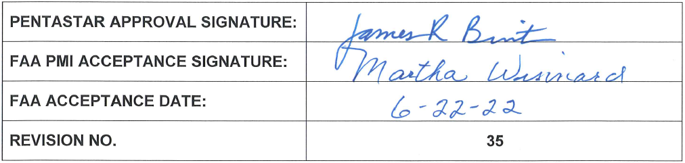
LIMITED RATING
POWERPLANT |  | MODEL NO. | LIMITATION
CFE COMPANY |  | CFE 738-1-1B | B
CFM INTERNATIONAL |  | CFM 56-7 | B
HONEYWELL INTERNATIONAL, INC. |  | TFE 731-2-3B | B
 |  | TFE 731-3-1C | B
 |  | TFE 731-3A-2B1 | B
 |  | TFE 731-3A-2B | B
 |  | TFE 731-3AR-2B1 | B
 |  | TFE 731-3AR-2B | B
 |  | TFE 731-3A-200G | B
 |  | TFE 731-3AR-3B1 | B
 |  | TFE 731-3AR-3B | B
 |  | TFE 731-3B-100S | B
 |  | TFE 731-3C-100S | B
 |  | TFE 731-3C-200G | B
 |  | TFE 731-3CR-100S | B
 |  | TFE 731-3R-100S | B
 |  | TFE 731-5AR-1C | B
 |  | TFE 731-5BR-1H | B
 |  | TFE 731-5BR | B
 |  | TFE 731-20AR | B
 |  | TFE 731-20R | B
 |  | TFE 731-20BR-1B | B
 |  | TFE 731-40AR | B
 |  | TFE731-50R | B
 |  | AS907-1-1A | B
 |  | AS907-2-1A | B
 |  | AS907-2-1G | B
 |  | AS907-3-1E | B
GENERAL ELECTRIC AIRCRAFT ENGINES |  | CF 34-1A | B
 |  | CF 34-3A | B
 |  | CF 34-3A1 | B
 |  | CF 34-3A2 | B
 |  | CF 34-3B | B
 |  | CJ 610-1 | B
 |  | CJ 610-4 | B
 |  | CJ 610-6 | B
 |  | CJ 610-8A | B
PRATT AND WHITNEY CANADA |  | JT 8D-219 | B
 |  | JT 15D-1 | B
 |  | JT 15D-1A | B
 |  | JT 15D-1B | B
 |  | JT 15D-4 | B
 |  | JT 15D-5 | B
 |  | JT 15D-5A | B
 |  | JT 15D-5B | B
 |  | JT 15D-5D | B
 |  | JT 15D-5F | B
 |  | JT 15D-5R | B
 |  | PW 206B / 206B2 / 206C | B
 |  | PW 305A | B
 |  | PW 306A | B
 |  | PW 306C | B
 |  | PW 308C | B
 |  | PW 535A | B
 |  | PW 535E | B
 |  | PW 545A | B
 |  | PT6A-60A | B
 |  | PT6A-66 | B
 |  | PT6A-66B | B
LIMITED RATING
POWERPLANT |  | MODEL NO. | LIMITATION
 |  | PW610F-A | B
 |  | PW814GA | B
 |  | PW815GA | B
ROLLS ROYCE CORPORATION (INDIANA) |  | AE3007C | B
 |  | AE3007C1 | B
ROLLS ROYCE DEUTSCHLAND LTD & CO KG |  | BR 700-710A1-10 | B
 |  | BR 700-710A2-20 | B
 |  | BR 700-710C4-11 | B
 |  | SPEY 511-8 | B
 |  | TAY 611-8 | B
 |  | TAY 611-8C | B
WILLIAMS-ROLLS, INC. INTERNATIONAL |  | FJ44-2A | B
 |  | FJ44-3A | B

LIMITATION
A | NONE
B | MANUFACTURES MAINTENANCE OR SERVICE INSTRUCTIONS, NOT INVOLVING THE MORE COMPLEX FUNCTIONS OF OVERHAUL

LIMITED RATING
AUXILLARY POWER UNITS | MODEL NO. | LIMITATION
ALLIED SIGNAL | RE-220 | B
GARRETT / HONEYWELL | GTCP 30-92C | B
 | GTCP 36-6 | B
 | GTCP 36-100 SERIES | B
 | GTCP 36-150 SERIES | B
 | GTCP 85-98DCB | B
 | HTG400G | B
 | 131-9 SERIES | B
SUNDSTRAND - TURBOMACH | T20G-10C3 | B
 | T62T-39 | B
 | T62T-40C3A1 | B
 | T62T-40C8D1 | B

LIMITATION
A | NONE
B | MANUFACTURES MAINTENANCE OR SERVICE INSTRUCTIONS, NOT INVOLVING THE MORE COMPLEX FUNCTIONS OF OVERHAUL

LIMITED RATING
PROPELLERS | MODEL NO. | LIMITATION
DOWTY – ROTOL | R390/4-123-F/27 | B
 | R389/4-123-F/26 | B

LIMITATION
A | NONE
B | MANUFACTURES MAINTENANCE OR SERVICE INSTRUCTIONS, NOT INVOLVING THE MORE COMPLEX FUNCTIONS OF OVERHAUL

LIMITED RATING
ACCESSORIES – ELECTRICAL INVERTERS | MODEL NO. | LIMITATION
FLITE TRONICS | PC-14 SERIES | A
 | PC-15 SERIES | A
 | PC-16 SERIES | A
 | PC-17 SERIES | A
 | PC-45 SERIES | A
 | PC-50 SERIES | A
 | PC-125 SERIES | A
 | PC-250 SERIES | A
 | PC-350 SERIES | A
 | MSI 800 | A

LIMITATION
A | NONE
B | MANUFACTURES MAINTENANCE OR SERVICE INSTRUCTIONS, NOT INVOLVING THE MORE COMPLEX FUNCTIONS OF OVERHAUL

LIMITED RATING
ACCESSORIES – POWER SUPPLIES | MODEL NO. | LIMITATION
AMP | 500 | A
 | 2000 | A
 | 2000A | A
JET | PS800 SERIES | A
 | PS823 SERIES | A
 | PS835 SERIES | A
 | PS855 SERIES | A
GRIMES | MODELS 60-0304 SERIES | A
 | MODELS 60-1177 SERIES | A
 | MODELS 10-0055 SERIES | A
 | MODELS 60-1321 SERIES | A
SECURAPLANE | XL245 | A
 | XL246-S | A
PAGE AEROSPACE | D734-02-001 | A

LIMITATION
A | NONE
B | MANUFACTURES MAINTENANCE OR SERVICE INSTRUCTIONS, NOT INVOLVING THE MORE COMPLEX FUNCTIONS OF OVERHAUL

